EE3311 B05 - Class Exercise 6
James McGinley

The goal of class exercise 6 was to make the design in class exercise 5 of an envelope detector with a non-zero bias current more realistic. We did this by adding several new components to our design which included the DC power supply connections.

In this exercise we assume that the diode bias current is 0.32 mA. This bias current corresponds to a resonance of the diode at 920 MHz. The resistance at resonance is no longer 100 Ω, but is now 104 Ω.

One of the major changes from exercise 5 was the addition of vias (plated holes). These vias are made to connect the tracks from one size on the board to another. The holes of the vias usually fall within the range of 0.5mm to 0.7mm.

Using Ansoft’s HFSS, we modeled these vias using perfect electric conductor (PEC) cylinders. For this exercise, we used closed PEC cylinders for our vias to simplify our design.

Several changes to the exercise 5 design were made. The new design can be seen in Figure 1.

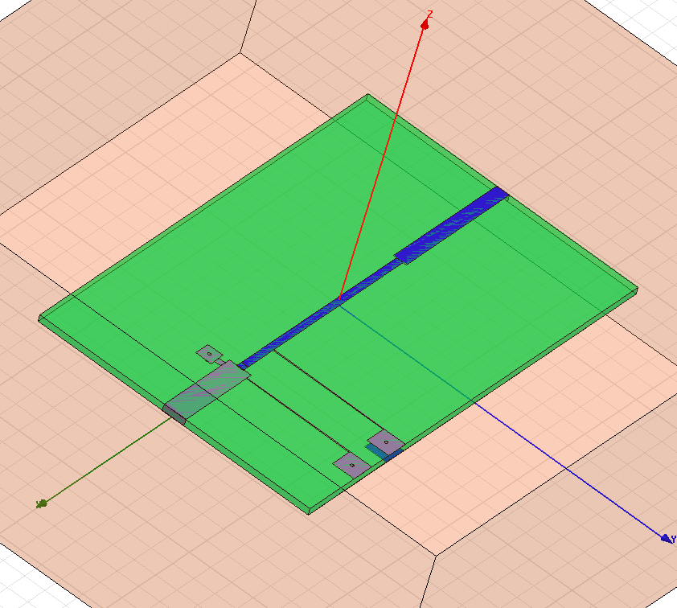
Figure 1: New envelope detector design

Using the design shown in Figure 1 we can determine the return loss. The return loss to the diode detector between 900 MHz and 940 MHz can be seen in Figure 2.

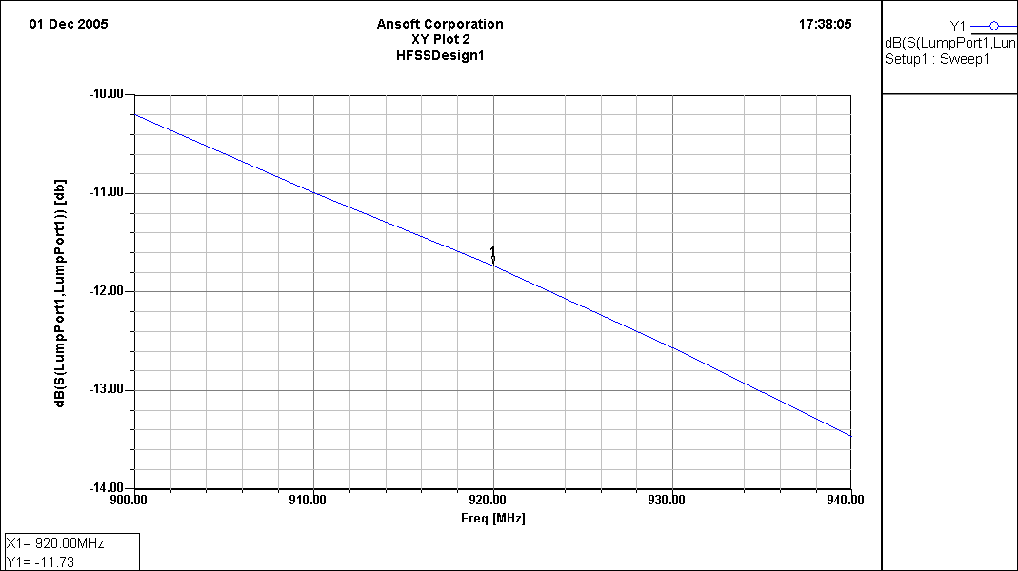
Figure 2: Return loss to the diode detector

As shown in Figure 2, the return loss of this diode detector is -11.73 dB at 920 MHz. This is considerably less than the return loss found in exercise 5, which was -30.55 dB at 920 MHz. This is due to the more realistic design used during this exercise.

In order to identify one reason for the degradation in the circuit performance, we looked at the surface current distribution on all of the top traces of the design shown in Figure 1. The current distribution can be seen in Figure 3.

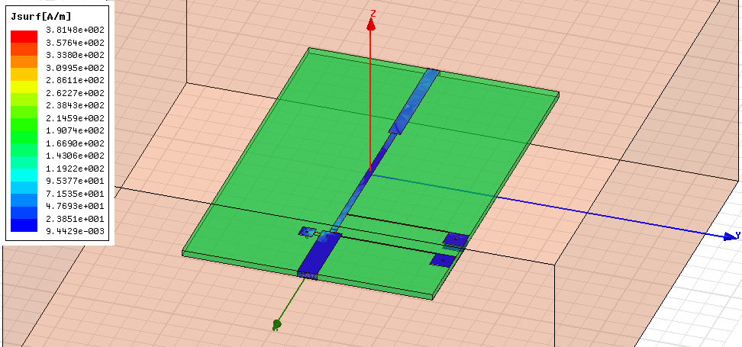
Figure 3: Current distribution of the envelope detector

Figure 3 shows that there is some RF flowing through the DC power buses. This leakage is a major cause to the lack of performance of this design to the one examined in exercise 5.

In order to fine tune this circuit, we varied the length of the quarter-wave transformer line. This was done by creating a parametric sweep from -20mm to 0mm in steps of 2mm. The results of this simulation can be seen in Figure 4.

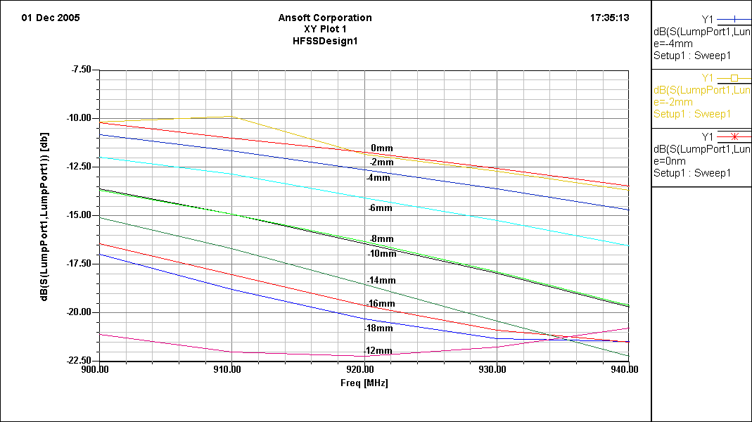
Figure 4: Parametric sweep results

Figure 4 shows that the optimal length is approximately -16mm. This is because a slight variation of the length in either the positive or negative direction does not cause a large jump in the return loss. The return loss at a length of -16mm and a frequency of 920 MHz is approximately -19 dB.

It is important to note that a length of -12mm might see to be the best solution, but we need to keep in mind that these simulations were not run with enough sweeps to ensure accurate results. By examining the other obtained lines, we can hypothesize that the line corresponding to -12mm is due to an inaccuracy in the Ansoft program.

The results attained in this exercise are not as impressive as those in exercise 5, but are more realistic. In order to obtain a higher accuracy we should take into account non ideal components and run the simulations for a longer time to create a more detailed mesh.

