EE3311 B05 - Class Exercise 2
James McGinley

The goal of class exercise 2 was to design a radiating microstrip element, which is also known as a microstrip patch antenna. We used Ansoft’s HFSS to model the probe-fed microstrip patch antenna that can be seen in Figure 1.

Figure 1: Microstrip patch antenna

We considered the patch to have a center frequency of 920 MHz and was place on FR4 epoxy with the relative dielectric constant ε_{r} = 4.4 and the loss tangent tan δ = 0.02. The thickness of the FR4 was 62 mm. The patch antenna and the ground plane were both considered to be perfect electric conductors. To model the probe feed for the microstrip patch we used a lumped port with port impedance equal to 50 Ω. This connection can be seen in Figure 2.

Figure 2: Port feed for the microstrip patch

The design was then placed into a larger box in order to create a radiation boundary to enable us to generate accurate results. This gave us the final structure used for our testing. The final design can be seen in Figure 3.

Figure 3: Final microstrip patch antenna design

Using this final design we ran a simulation using 15 passes and a frequency sweep from 800 MHz to 1 GHz using a step size of 2.5 MHz. This simulation allowed us to create the plot shown in Figure 4, which shows the input impedance of the patch antenna.

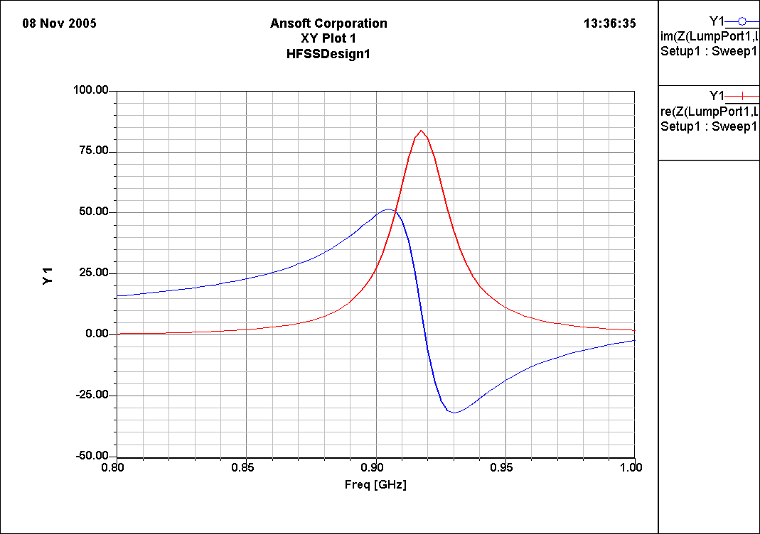
Figure 4: Input impedance of the patch antenna with 15 passes

As seen in FIG, the resonant frequency of this patch antenna is approximately 920 MHz. The antennas resistance at resonance is approximately 84 Ω. This is higher than the desired 50 Ω due to the probe feed being located at the end of the patch instead of at an optimal location in between the center and the end of the patch.

Next, we looked at the return loss for this patch antenna. The results can be seen in Figure 5.

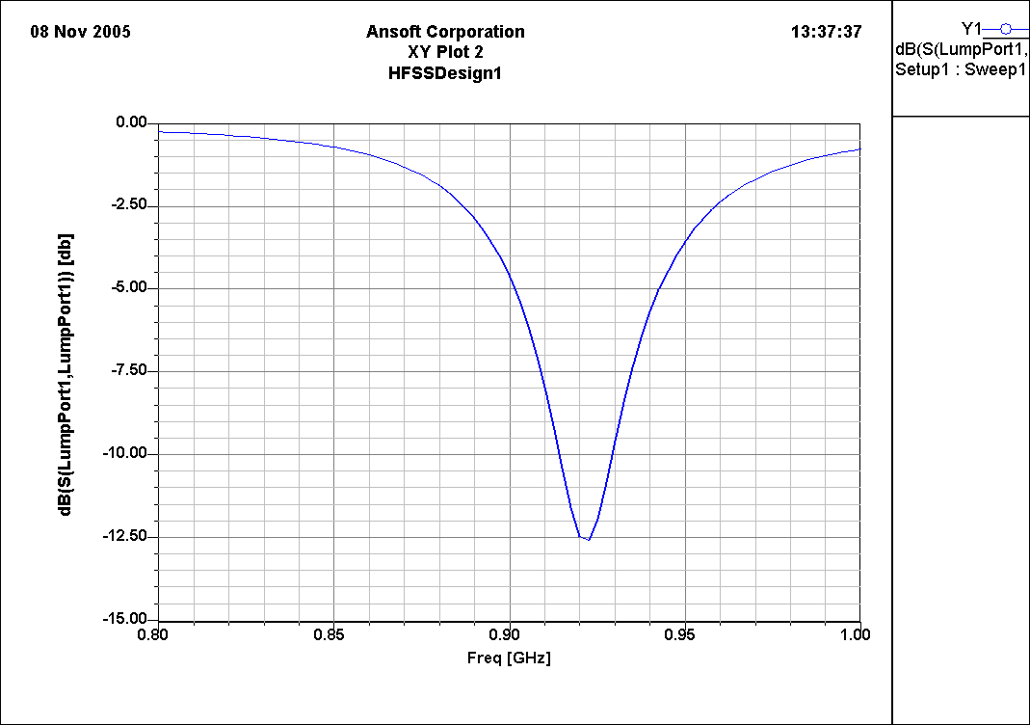
Figure 5: Return loss of the patch antenna using 15 passes

Figure 5 was obtained by plotting the magnitude of the reflection coefficient S₁₁ in dB. Using these results we can estimate the antenna bandwidth percentage according to Eq. (1), which yields approximately 16.304%.

$B=\frac{Δf(\text{Return Loss }<\text{ -10dB})}{f_{c}}\text{x 100\%}$ (1)

We then examined the radiation pattern of the patch antenna. Using a far-field infinite sphere in HFSS we were able to create a graph with the total gain in dB which is seen in Figure 6.

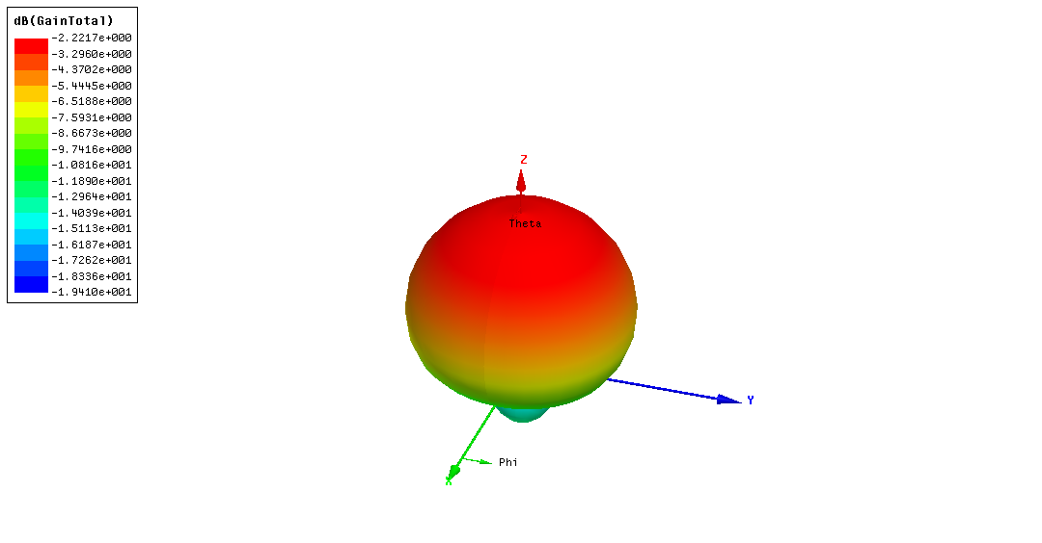
Figure 6: Total gain in dB of the patch antenna using 15 passes

As can be seen in Figure 6, the patch antenna is directional, with the main beam pointing toward zenith. The gain of this antenna can also be seen to be a max of -2.2217 dB. This is due to the losses inherent when using FR4 material. To see the total gain in dB assuming no losses, we looked at the total directivity in dB, which can be seen in Figure 7.

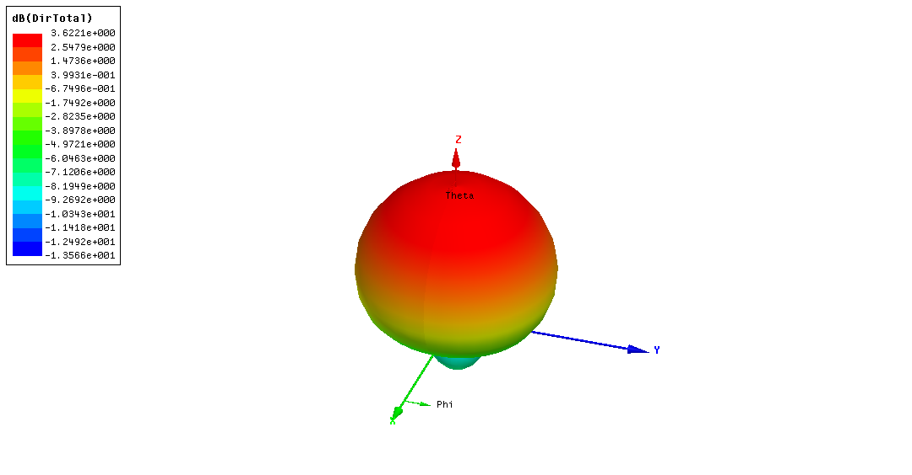
Figure 7: Total directivity in dB of the patch antenna using 15 passes

Figure 7 shows us that by using the FR4 material we lose close to 6 dB from out antenna which will in turn cause us the need to use an amplification circuit in conjunction with this antenna to acquire the gain we desire. Without any losses from the FR4 material we would have a gain of approximately 3.6221 dB.

To optimize this patch antenna we can use either numerical analysis or experimental analysis to find the best location of the probe feed. The numerical analysis is based off of the approximate Eq. (2).

$R(d)≈\text{85}\text{cos}\left(\frac{π(\frac{L}{2}−d)}{L}\right)$ (2)

Using (2) and assuming L = 76.5 mm and R(d) = 50 Ω, we can determine that d = 513.88 mm. Using (2), we understand that the resulting d value is not expected to be accurate since there is no exact analytical model for any antenna or antenna feed except for the “electrically small antennas.”

We then ran a parametric sweep with the location of the probe feed as a variable from 20.25 mm to 38.25 mm using a step size of 2.00 mm. Running this simulation we obtained the results shown in Figure 8.

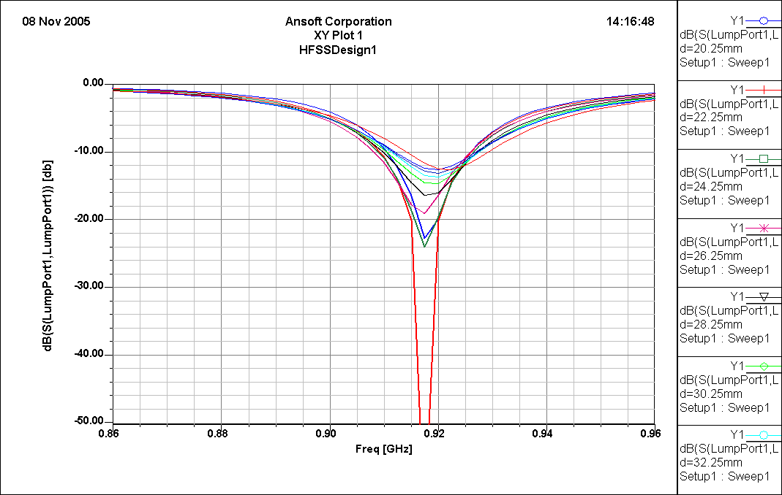
Figure 8: Return loss in dB using a parametric sweep for a variable probe feed location

The topmost red line is for the original probe feed location of 38.25 mm. The bottommost red line is for the probe feed location of 22.25 mm. Although this gives us the lowest return loss, it also shifts the frequency down slightly. To correct this we needed to make the length of the patch antenna slightly smaller. We reduced the length of the patch to 76 mm by 76 mm and used a probe feed at a location of 20.25 mm to obtain Figure 9.

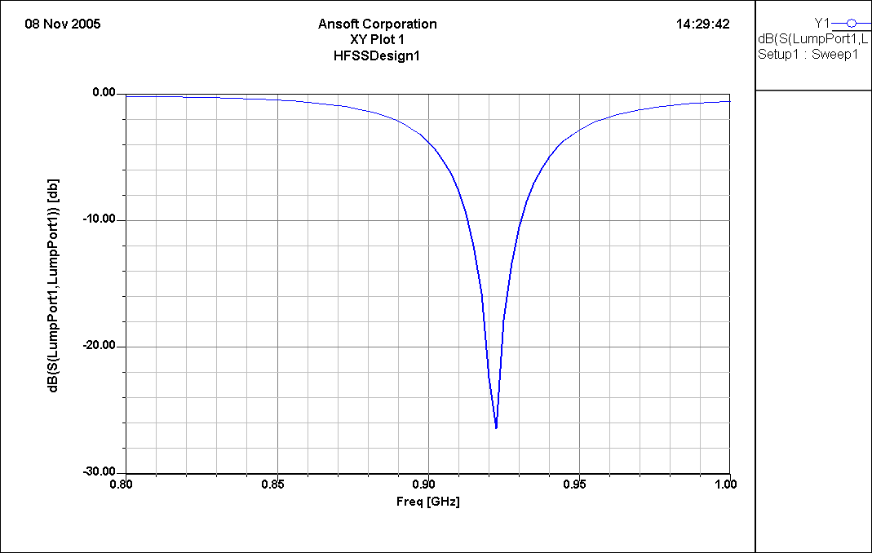
Figure 9: Optimized patch antenna return loss in dB

Using this modified patch antenna we were able to optimize the return loss to a certain extent. If we were to increase the length slightly, the frequency would be shifted down slightly and we might be able to achieve an exact resonant frequency of 920 MHz.

Using Eq. (1) we can calculate the bandwidth percentage of this patch to be approximately 2.2 %. If we had more time we would have run another parametric sweep using varying patch lengths and probe feed locations at small steps to obtain the optimal patch length and probe feed location. The optimal patch length and probe feed will enable us to achieve the best return loss for this antenna design.

From this class exercise we have learned the importance of the material used when designing devices such as antennas. We have also demonstrated the importance of the placement of the probe feed and the length of the patch in the overall performance of the antenna.

