Potential antenna designs for a wearable antenna at 440 MHz
Planar inverted-F antenna (PIFA)

The planar inverted –F antenna is popular for portable wireless devices because of its low profile, small size, and built-in structure [1]. The other major advantages are easy fabrication, low manufacturing cost, and simple structure [2]. Also, PIFA’s inherent bandwidth is higher than the bandwidth of the conventional patch antenna (since a thick air substrate is used).

The basic PIFA (a “grounded” patch antenna - λ/4 patch length instead of the conventional λ/2) consists of a ground plane, a top plate element, a feed wire feeding the resonating top plate, and a DC-shorting plate that is connecting the ground and the top plate at one end of the resonating patch.

a. Design
Fig 1 shows the geometry of the quarter PIFA element optimized for 440 MHz. This design is essentially adopted from Ref. [3].

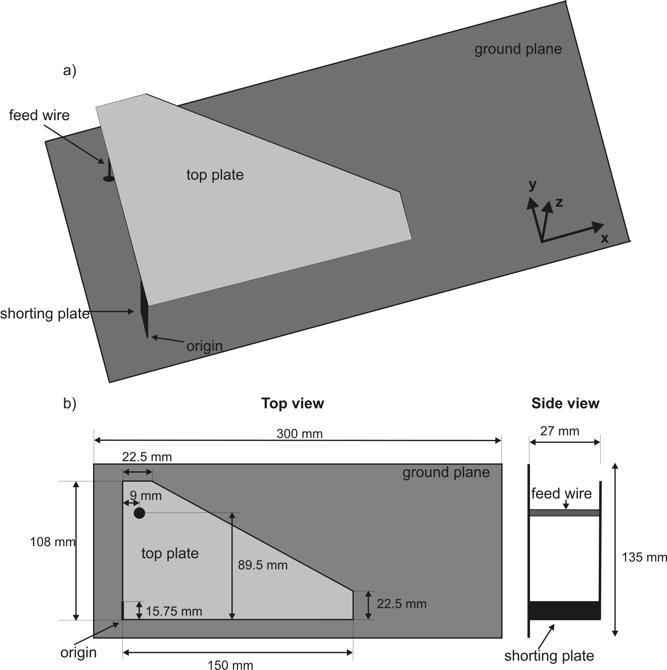

Fig.1. A PIFA structure optimized for 440 MHz. -a) the isometric view; -b) the top view and side view of the antenna.

The classical PIFA design techniques are used to make a quarter-wavelength resonant patch for the required resonant frequency while the height of the top plate above the ground plane is fixed ($0\text{.}\text{04}λ$). The location of the shorting plate and feeding point is optimized in order to achieve the best matching.

b. Performance
As shown in Fig. 2, the maximum return loss is -36.45 dB at 441 MHz. The upper and lower band frequencies are 410 MHz and 474 MHz, respectively, giving the absolute bandwidth of 64 MHz. Therefore, the bandwidth obtained for the proposed PIFA is 14.55%.

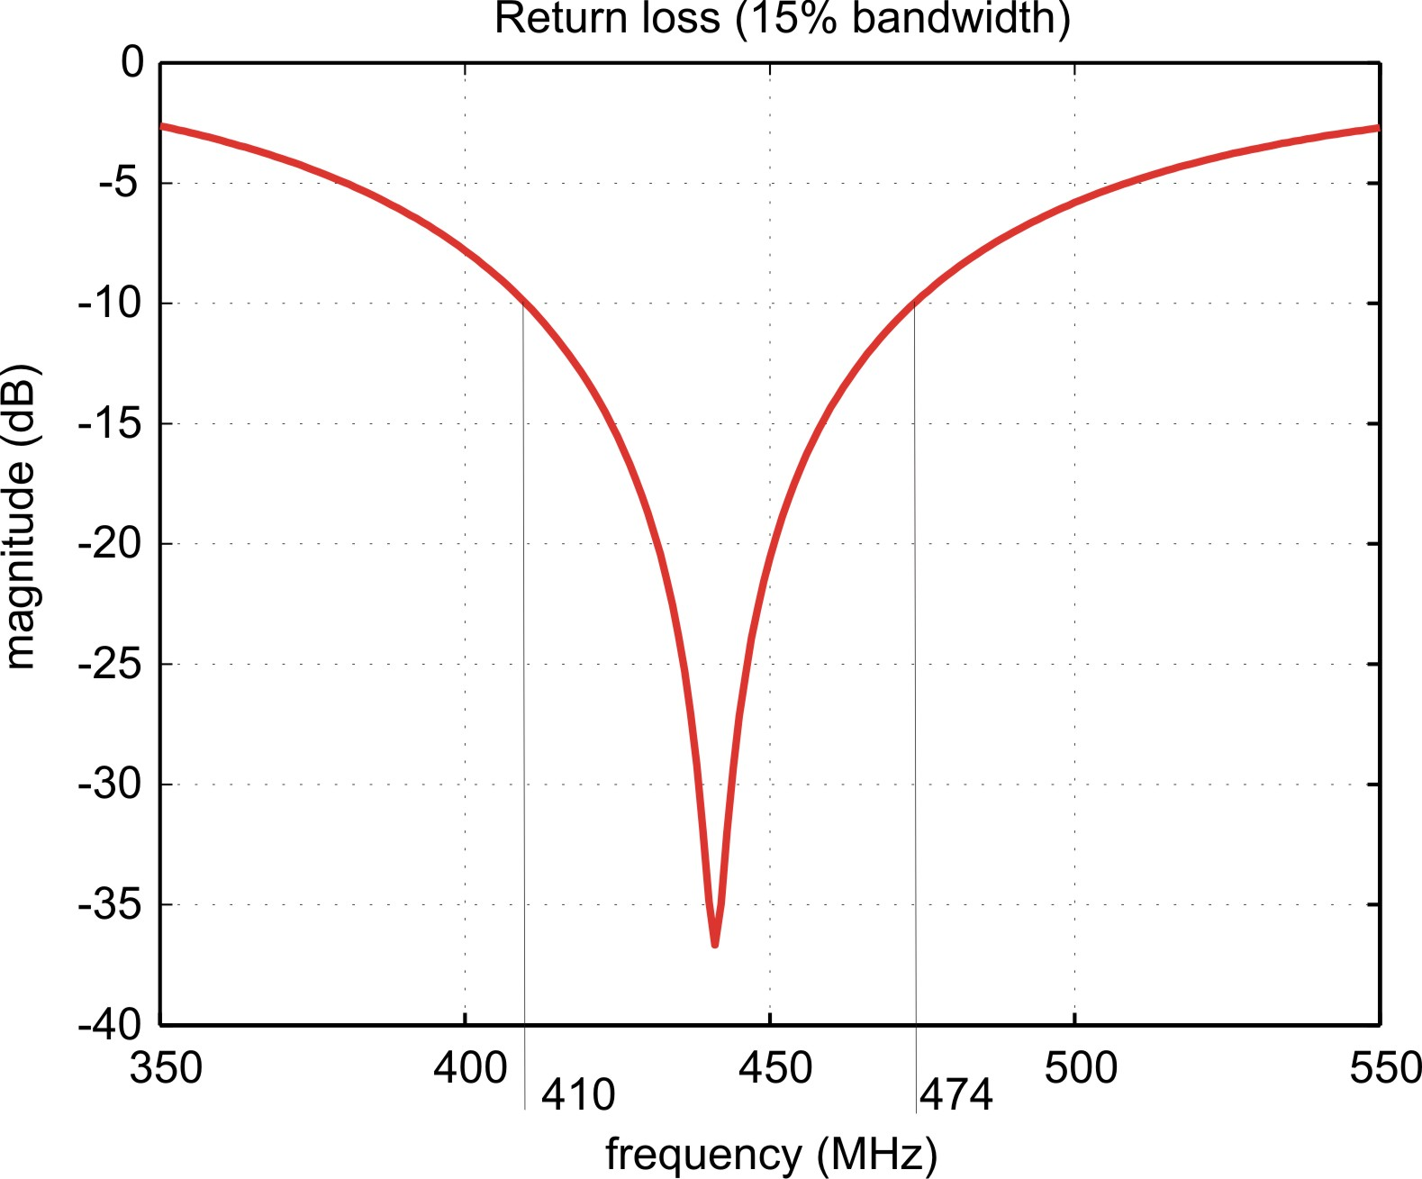

Fig.2. Return loss for the PIFA structure shown in Fig 1.

The 3D total radiation pattern (absolute gain) is shown in Fig. 3. The maximum gain of the antenna is about 2 dB along the vertical z-axis (the axes are shown in Fig. 1). Fig. 4 shows the gain variation of the antenna in the xz plane (the E-plane of the antenna).

The PIFA is thus a directional, linearly-polarized antenna, with an acceptable front-to-back ratio. Fig.5 shows the polarization isolation plot in the E-plane.

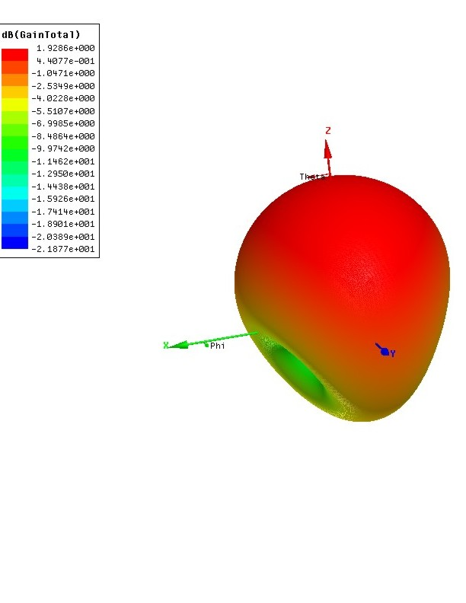
Fig.3. 3D radiation pattern (absolute gain).

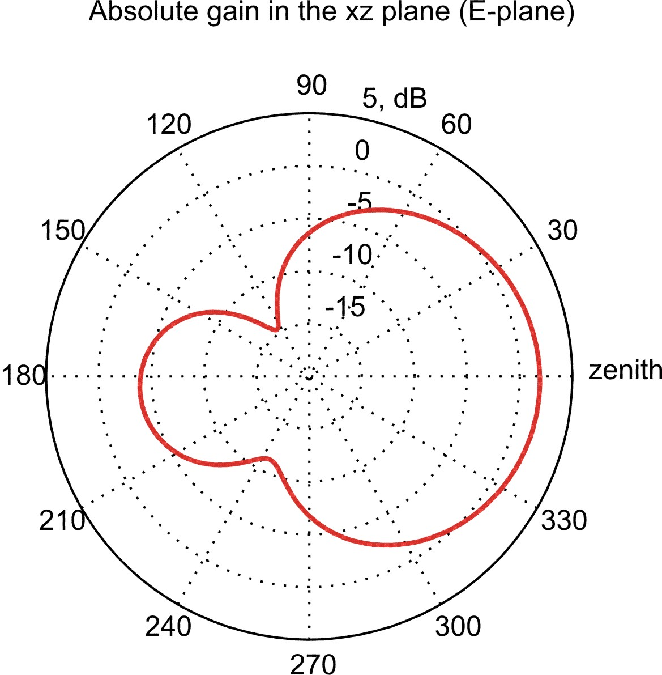

Fig.4. 2D radiation pattern in the xz plane (absolute gain).

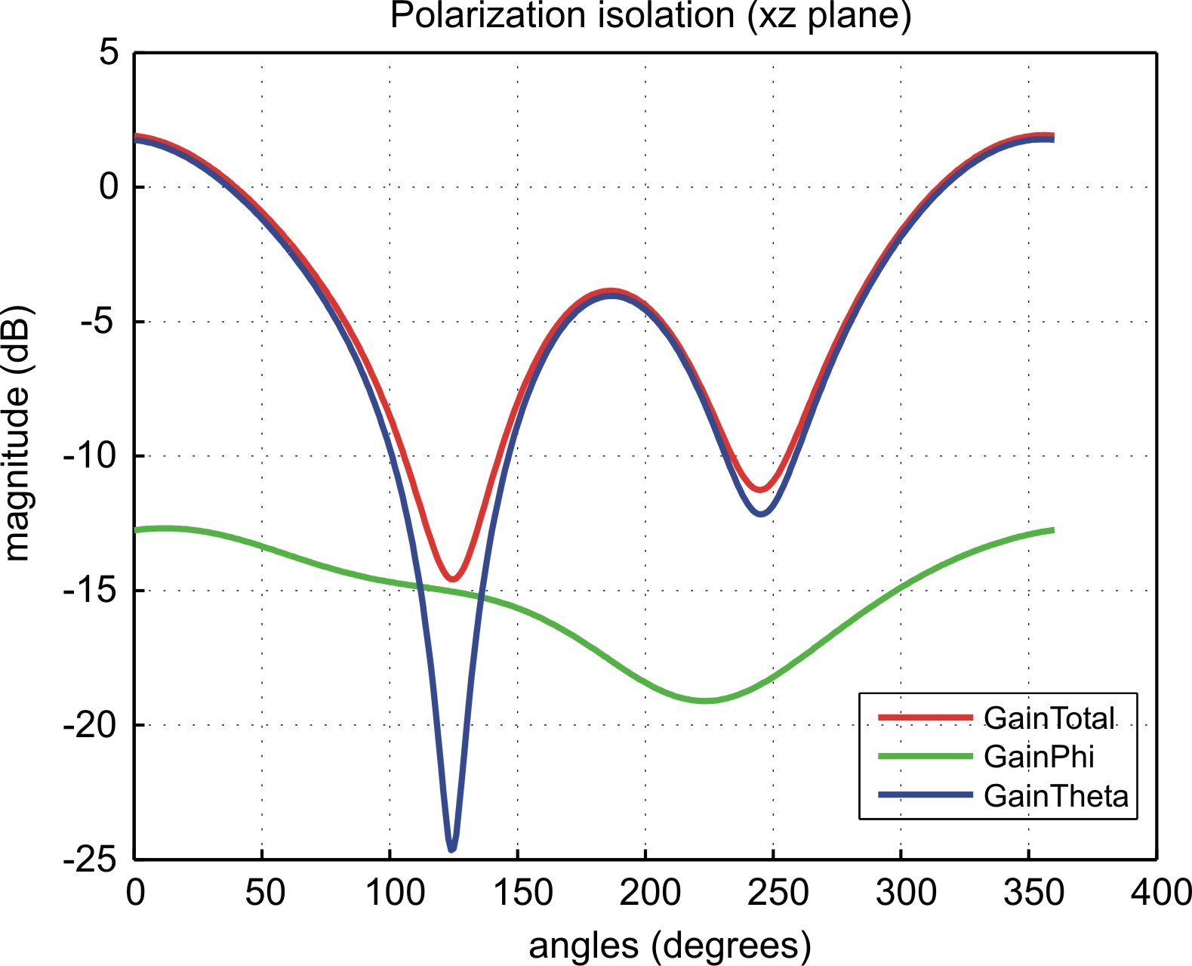

Fig.5. Co-polarization and cross-polarization radiation patterns in the E-plane.

References

- F. Wang, Z. Du, Q. Wang and K. Gong, “Enhanced-bandwidth PIFA with T-shaped ground plane”, Electronic Letters, vol. 40, no. 23, pp. 1504 – 1505, Nov. 2004.

- B. Kim, J. Hoon and H. Choi, “Small wideband PIFA for mobile phones at 1800 MHz,” Vehicular Technology Conference, vol.-1, pp. 27-29, May 2004.

- B. Kim, J. Park and H. Choi, “Tapered type PIFA design for mobile phones at 1800 MHz,” Vehicular Technology Conference, vol.-2, pp. 1012-1014, April 2005.

