DUPLICATING and BINDING

Please follow these simple instructions when you duplicate the projects and bind them for delivery.

General Duplicating and Binding Instructions
- You should print the FIRST copy of your report from the PDF file that includes all appendices.
- Print the FIRST copy entirely on your printer, using a good cartridge.
- This printout should be bound at the copy center near the VPC (See map below).
- Duplicate reports will then be generated using an electronic printing service (more information as needed)
- Duplicate copies should be printed double-sided.

General Duplicating Instructions
- Print all color pages on a printer. Color copies are too expensive.
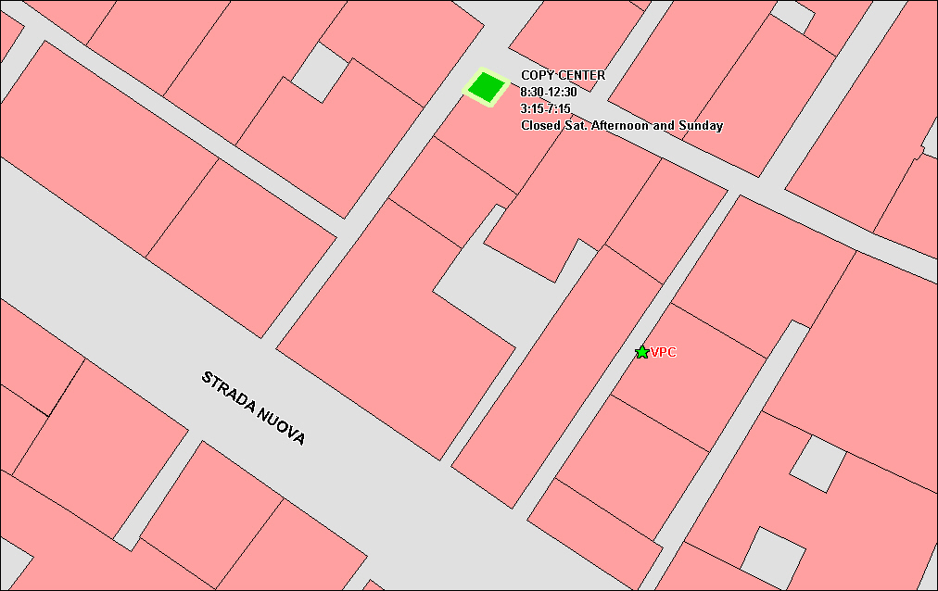
Figure 1. The Copy Center with respect to the VPC office.
- Duplicate all B/W pages
- Do not copy on both sides of paper (color pages will not work out, since they are on separate sheets)
- For the exact number of copies to make, refer to separate Handout ("Delivering the Deliverables").
- Team and advisors should develop a list of recipients of project deliverables, indicating who gets the printed report, the CD, both or neither (or something else).

General Binding Instructions
- Put a clear plastic sheet over the cover.
- Put a thick plastic or cardboard on the back for protection and support.
- Use white spirals, so we can write on them. Make sure they are writable and/or that we can stick a label on them.

Directions to Copy Center near VPC
The copy center we usually work with is right around the corner from the VPC. See Figure 1. The hours are subject to change. The latest time for binding is 7:30pm on FRIDAY July 29th (ignore the schedule on the map).

