FINAL CD-ROM(S) PREPARATION

In order to make possible the continuation of your projects by future IQP groups, all project teams are REQUIRED to submit complete and well-organized CD-ROM(s) containing the entire PQP and IQP results. The CD will be organized as described herein and it will all be accessible through a web interface (your project’s web page) as a standalone web site.

GENERAL INSTRUCTIONS
Generally speaking, the following basic instructions must be followed by ALL teams:
- Use (rewritable) CDs for temporary storage of drafts during IQP. Use a version number to label your drafts as you go along (e.g. Report v1.1.doc), and periodically save past draft versions onto CDs. DO NOT rely on Hard Disks alone for data storage!
- Use CD ROM for final storage of ALL PQP/IQP FILES. Each disk should be properly labeled and a cover should be printed as well (see below).
- The CD-ROM should contain ONLY the FINAL versions of all the files! Please, NO JUNK. This is EXTREMELY IMPORTANT. All directories and files should be named using the conventions listed below.
- DOUBLE CHECK the validity of the data on the disks! To do this: open the files with the appropriate program, reading them directly from the CD-ROM drive. This will also be useful to check if some necessary files are missing.

The following sections provide step-by-step instructions about the preparation of the computer files and should be carried out in the order presented here.

Organize Files in Appropriate Directories (on HARD DISK)
On your hard disks, create the following FOLDERS, when applicable (see also Figure 1):

- REPORT (or TEXT), for the Word Processor files (.DOC) organized appropriately (including appendices)
- ACROBAT, for the Acrobat (.PDF) file that will contain the entire report.
- EXCEL, for Excel Worksheets and graphs (.XLS).
- GRAPHS, for graphs NOT done with Excel, also may include any raster (JPG) image of graphs used in text.
- DATABASE, for the (Access) database files (.MDB).
- MAPS, for the (Mapinfo) map files (.DAT, :TAB, .MAP, .ID, .WOR.)
BE CAREFUL! Mapinfo creates a lot of files and it is easy to FORGET some of them! Double check the success of the copy by trying to open the COPIES of the Mapinfo layers.
- PRESENTATION, Powerpoint slides (.PPT) (BE CAREFUL with accessory files, like sound effects)
- WEB, All HTML web pages, including FRONTPAGE files (.HTM or .HTML) and others (BE CAREFUL with images and other accessory files)
- FIGURES, for all raster images that were used as FIGURES in the text of the report. These should be also included in the IMAGES directory (where applicable). Suggested format is JPEG (.JPG).
- IMAGES, for all other raster images (e.g. Photoshop, Scanner, .WMF, .BMP, .JPG, .TIF, etc.). Since this directory may be rather crowded, create SUB-FOLDERS as needed, to organize the files, using appropriate mnemonic names for sub-directories. If your project includes many images used to document your field inventories, you may decide to put all of those images in one or more separate CDs.
- OTHER, for all files you don't know where to put.

Appropriately Name Root Directory for all Project Files (on Hard Drive)
All of your well-organized and appropriately named directories should be placed under a ROOT directory called:

TERM_<short project name>

For example: E00_Wellheads, or E00_Belltowers, or E03_Cambridge_Traffic, E05_Lagoon, etc.

Figure 1 demonstrates how a properly organized project folder should look. Your final CD should also look more or less like this (some sub-folders may be omitted if unnecessary). The short name of the project in this example is E00 Public Art.

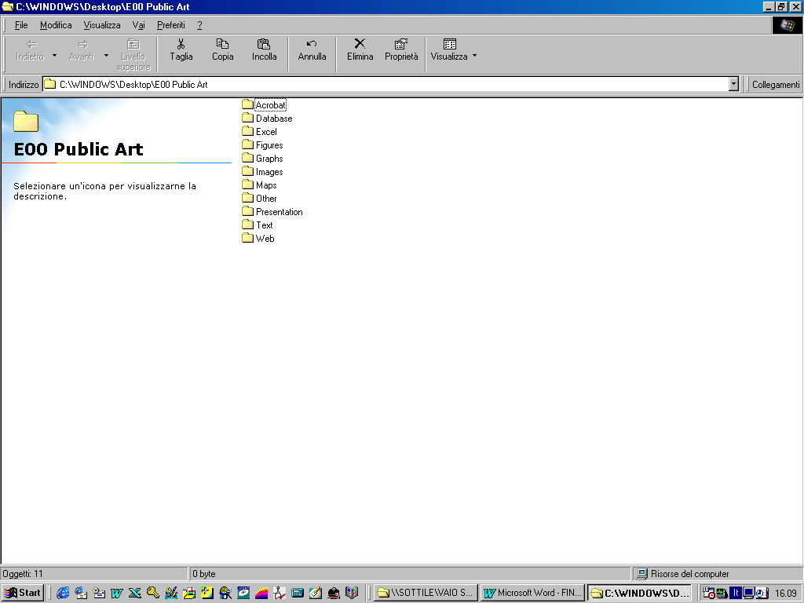Figure 1. Example of a properly organized project folder (E00 Public Art) with all of its sub-folders.

Copy appropriate files to above Directories on Hard Drive
Copy the appropriate files into each of the above directories. If you have any questions, ask Prof. Carrera. The following table summarizes what files go where:

Application | Extensions | Copy to Directory | Notes
Word | .DOC | TEXT | NO .BAK or .TMP files, please
Acrobat | .PDF | ACROBAT | The entire report should be saved in Acrobat format at the very end.
Powerpoint | .PPT | PRESENTATION | watch out for small, but necessary accessory files
Frontpage | .HTM, .HTML | WEB | watch out for small, but necessary accessory files
Access | .MDB | DATABASE | Make sure that unnecessary tables are deleted
Excel | .XLW/.XLS | EXCEL | avoid .XLC
Mapinfo | .MAP, .DAT, .TAB, .ID, .WOR | MAPS | make sure to include ALL four types of files!!! VERY IMPORTANT! There may be others as well
Photoshop, Ezphoto, Mapinfo, etc. | .JPG, .WMF, .BMP, .TIF, etc. | IMAGES | could be produced by scanner, "save window as" in Mapinfo (.WMF or .BMP), or obtained by capturing a screen or with Digital Camera
same | same | FIGURES | keep image files that appear as FIGURES in report separated from the other images (IF APPLICABLE)
Other | ??? | OTHER | in case there are unusual files created with special applications

Test files by opening them at their new location!

Rename .DOC files and give them proper, useful names (on Hard Disk)
The TEXT sub-folder will contain all Word Processing files (Word for Windows). The entire report should be completely electronic. There ought to be NO pasted figures in your report. If needed, you should scan in whatever paper materials you want to include in your document, so that the whole thing can be reproduced from your files and no other action is necessary.

- A single .DOC file should be created which contains the entire report, including figures and Appendices. The file name clearly identify its contents and should always be preceded by the term. For example, D05_Boston_EIR.doc, D05_Cambridge_Crosswalks.doc, E05_Venice_Stores.doc, etc. Use underscores instead of spaces.

Rename files containing Figures
Even though the figures may have been saved with the .DOC file(s), it is useful to keep the original raster images, if they are available, on separate files. These should be saved in the FIGURES directory and should very simply be named according to the figure number: FIG_01, FIG_02, etc. The extensions don't matter, even if they are all different. For single-digit figures, use leading zeros to facilitate sorting (FIG_01, FIG_02 etc.).

Make Frequent Backups on CD ROMs
It is highly recommended that you periodically save all your files in a (Rewritable) CD as you go along, to prevent catastrophic data loss.
- Copy the well-organized files and directories into one or more CDs as backups. Do this as frequently as possible throughout the term.
- Use additional CDs as necessary.
- Label each CD appropriately (see below)

Make sure the Web Page links are RELATIVE to the main web page
Do not hardcode the actual UNIX directories of your files into the HTML web pages. Instead, you should use relative links off of the main web page that will reside on the root directory of the CD. For example, since your project report (let’s say it is called D05_Boston_EIR.doc) will be inside the folder called REPORT on the CD, your main web page (assume it is called D05_Boston_EIR.html) will link to the report like this:
REPORT/D05_Boston_EIR.doc
Instead of
/home/smith/IQP/REPORT/D05_Boston_EIR.doc (assuming the student’s username is Smith)

Make final CD-ROM(s)
The Final CD ROM will consist of an image of your Hard Drive Directory, which will have the main HTML file in the root and will behave as a standalone web site thanks to all the RELATIVE links in it.
For the IQP, you’ll need to burn multiple copies (see separate handout about final deliverables). You probably will want to make a copy for yourselves too. The process can take hours, so enough time must be allotted for this final step, so that everyone gets a CD-ROM made before departing. Priority will be given to official CD-ROMs. Other copies will be made only if time permits.
It is possible that you may have to separate digital photos if too numerous (as usually happens in the case of catalog projects) and burn a CD just for them.

Use an Appropriate Volume Label for the CD
You should make sure that you assign the CD a VOLUME label. This will be the label of the CD ROM when looking at the Drives list. Use an even shorter version of your Root Directory name if needed (12 characters max):
TERM_<shorter project name>

For example: E00_Wellheads, or E00_Belltowers, or E03_Traffic, etc.

Remember that this is the label that will show up next to the CD icon under the File Manager or Explorer in Windows.

Check Final CD-ROM(s)
You should check that the Final CD-ROM is OK, by opening the various files directly from the CD. In particular, you should:

- Open the .DOC file(s) in Word
- Open the PDF file in Acrobat
- Open the project MAPS in Mapinfo
- Open the Access Database(s)
- Open the Excel Spreadsheet(s)
- Open the Powerpoint Presentation
- Browse the Web pages locally
- Randomly check all other files.

Professionally Label CD-ROM(s)
Professional labels should be used to produce covers for both the CD disk and Jewel Case. The labels will contain the following information:
- Title of Project
- Name and Logo of Sponsoring Agency
- WPI logo
- Term (e.g. E05)
- Contents (FINAL REPORT, IMAGES, etc.) – on back of jewel case
- Disk Number (Disk 1 of 2, Disk 2 of 2, etc.) - on Disk and back of jewel case

More information about free labeling software and samples can be found on line at:

http://www.wpi.edu/Academics/Depts/IGSD/Projects/Venice/Center/ID2050/Handouts/Handouts.html

Make your Labels look PROFESSIONAL!!! Impressions are important too!!!
Let your pride in the project be reflected by the label!

Do not leave any JUNK in the CD (old files, temp files, useless files). Clean everything up and make it tight and PROFESSIONAL.

Remember that the CD is probably the MOST IMPORTANT
heritage you'll leave behind, even more valuable than your
project report (which is contained therein anyway).

